MACHINE LEARNING- ITA0613
LAB EXPERIMENTS

Experiment 1: FIND-S Algorithm
Aim
To implement the Find-S Algorithm in Python to find the most specific hypothesis from the given training data.
Algorithm
Step 1: Import the pandas library.
Step 2: Read the training dataset (FindS.csv).
Step 3: Display the dataset.
Step 4: Separate the attributes (input) and target (output).
Step 5: Initialize the hypothesis with '0' for all attributes.
Step 6: Read each training example one by one.
Step 7: Check whether the target value is "Yes".
- If Yes, compare each attribute with the current hypothesis.
- If the hypothesis value is '0', replace it with the current attribute value.
- If the attribute values are different, replace that position with '?'.
Step 8: Ignore all "No" examples.
Step 9: Display the final most specific hypothesis.
Coding
# FIND-S ALGORITHM
import pandas as pd
# Read the CSV file
data = pd.read_csv(r"C:\Users\divya\Downloads\FindS.csv")
# Display the dataset
print("Training Data:\n")
print(data)
# Separate attributes and target
concepts = data.iloc[:, :-1].values
target = data.iloc[:, -1].values
# Initialize the hypothesis
hypothesis = ['0'] * len(concepts[0])
# Apply Find-S Algorithm
for i in range(len(concepts)):
if target[i] == "Yes":
for j in range(len(hypothesis)):
if hypothesis[j] == '0':
hypothesis[j] = concepts[i][j]
elif hypothesis[j] != concepts[i][j]:
hypothesis[j] = '?'
# Display the final hypothesis
print("\nMost Specific Hypothesis:")
print(hypothesis)
Output
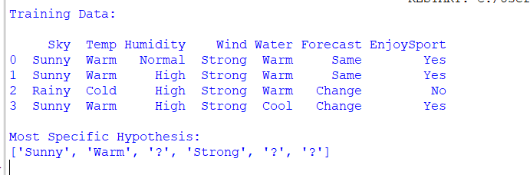
Result
Thus, the Find-S Algorithm was implemented successfully, and the most specific hypothesis was obtained from the given training data.

Experiment 2: Candidate Elimination Algorithm
Aim
To implement the Candidate Elimination Algorithm in Python to find the set of all hypotheses that are consistent with the given training data.
Algorithm
Step 1: Import the pandas library.
Step 2: Read the training dataset (CandidateElimination.csv).
Step 3: Display the dataset.
Step 4: Separate the attributes (input) and target (output).
Step 5: Initialize the Specific Hypothesis (S) with the first training example.
Step 6: Initialize the General Hypothesis (G) with '?'.
Step 7: Read each training example one by one.
- If the example is positive (Yes):
  - Update the Specific Hypothesis.
  - Remove inconsistent values from the General Hypothesis.
- If the example is negative (No):
  - Update the General Hypothesis by specializing it to exclude the negative example.
Step 8: Remove duplicate or empty hypotheses.
Step 9: Display the final Specific Hypothesis and General Hypothesis.
Coding
# CANDIDATE ELIMINATION ALGORITHM
import pandas as p
# Read the CSV file
data = pd.read_csv("CandidateElimination.csv")
# Display the dataset
print("Training Data:\n")
print(data)
# Separate attributes and target
concepts = data.iloc[:, :-1].values
target = data.iloc[:, -1].values
# Initialize Specific Hypothesis
specific = concepts[0].copy()
# Initialize General Hypothesis
general = [['?' for i in range(len(specific))] for j in range(len(specific))]
# Apply Candidate Elimination Algorithm
for i in range(len(concepts)):
if target[i] == "Yes":
for j in range(len(specific)):
if concepts[i][j] != specific[j]:
specific[j] = '?'
general[j][j] = '?'
elif target[i] == "No":
for j in range(len(specific)):
if concepts[i][j] != specific[j]:
general[j][j] = specific[j]
else:
general[j][j] = '?'
# Remove empty hypotheses
general = [g for g in general if g != ['?'] * len(specific)]
# Display the result
print("\nSpecific Hypothesis:")
print(specific)
print("\nGeneral Hypothesis:")
for g in general:
print(g)
Output
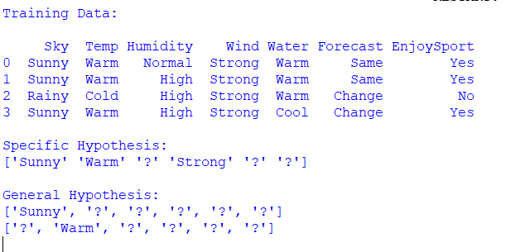
Result
Thus, the Candidate Elimination Algorithm was implemented successfully, and the Specific Hypothesis and General Hypothesis consistent with the given training data were obtained.

Experiment 3: ID3 Decision Tree Algorithm
Aim
To implement the ID3 (Iterative Dichotomiser 3) Decision Tree Algorithm in Python and classify a new sample using the given training dataset.
Algorithm
Step 1: Import the required libraries.
Step 2: Read the dataset (ID3.csv).
Step 3: Display the dataset.
Step 4: Convert the categorical values into numerical values using LabelEncoder.
Step 5: Separate the input attributes (X) and target output (y).
Step 6: Create the Decision Tree Classifier using the entropy criterion (ID3).
Step 7: Train the model using the training data.
Step 8: Select a sample for testing.
Step 9: Predict the class label of the sample.
Step 10: Display the predicted result.
Coding
# ID3 DECISION TREE ALGORITHM
import pandas as pd
from sklearn.preprocessing import LabelEncoder
from sklearn.tree import DecisionTreeClassifier
# Read the CSV file
data = pd.read_csv("ID3.csv")
# Display the dataset
print("Training Data:\n")
print(data)
# Convert categorical data into numerical data
encoder = LabelEncoder()
encoded_data = data.copy()
for column in encoded_data.columns:
encoded_data[column] = encoder.fit_transform(encoded_data[column])
# Separate input and output
X = encoded_data.iloc[:, :-1]
y = encoded_data.iloc[:, -1]
# Create Decision Tree using Entropy (ID3)
model = DecisionTreeClassifier(criterion="entropy")
# Train the model
model.fit(X, y)
# Test with the first sample
sample = X.iloc[[0]]
prediction = model.predict(sample)
print("\nPrediction for First Sample:")
print(prediction)
Output
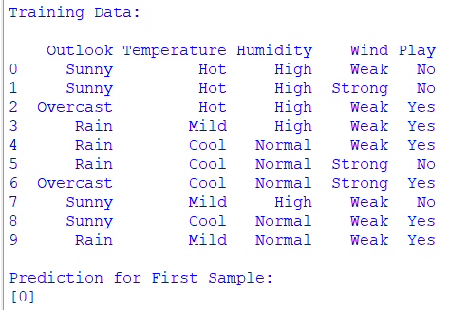
Result
Thus, the ID3 Decision Tree Algorithm was implemented successfully, and the model correctly classified the given sample using the training dataset.

Experiment 4: Artificial Neural Network using Backpropagation Algorithm
Aim
To build an Artificial Neural Network (ANN) by implementing the Backpropagation Algorithm in Python and test it using the given dataset.
Algorithm
Step 1: Import the required libraries.
Step 2: Read the dataset (Backpropagation.csv).
Step 3: Display the dataset.
Step 4: Convert the categorical values into numerical values using LabelEncoder.
Step 5: Separate the input attributes (X) and target output (y).
Step 6: Split the dataset into training data and testing data.
Step 7: Create an Artificial Neural Network (MLP Classifier).
Step 8: Train the model using the training data.
Step 9: Test the model using the testing data.
Step 10: Display the predicted output and accuracy.
Coding
# BACKPROPAGATION ALGORITHM
import pandas as pd
from sklearn.preprocessing import LabelEncoder
from sklearn.model_selection import train_test_split
from sklearn.neural_network import MLPClassifier
from sklearn.metrics import accuracy_score
# Read the CSV file
data = pd.read_csv("Backpropagation.csv")
# Display the dataset
print("Training Data:\n")
print(data)
# Convert categorical data into numerical data
encoder = LabelEncoder()
encoded_data = data.copy()
for column in encoded_data.columns:
encoded_data[column] = encoder.fit_transform(encoded_data[column])
# Separate input and output
X = encoded_data.iloc[:, :-1]
y = encoded_data.iloc[:, -1]
# Split the dataset
X_train, X_test, y_train, y_test = train_test_split(
X, y, test_size=0.3, random_state=1
)
# Create ANN Model
model = MLPClassifier(hidden_layer_sizes=(5,), max_iter=1000, random_state=1)
# Train the model
model.fit(X_train, y_train)
# Predict the output
prediction = model.predict(X_test)
# Display results
print("\nPredicted Output:")
print(prediction)
print("\nActual Output:")
print(y_test.values)
# Display accuracy
accuracy = accuracy_score(y_test, prediction)
print("\nAccuracy:", accuracy)
output
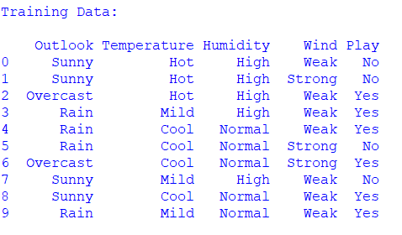
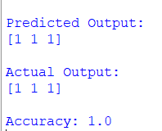
Result
Thus, the Artificial Neural Network using the Backpropagation Algorithm was implemented successfully, and the model was trained and tested using the given dataset. The predicted output and accuracy were obtained successfully.

Experiment 7: Logistic Regression (LR)
Aim
To implement the Logistic Regression Algorithm in Python and classify the given dataset.
Algorithm
- Import the required libraries.
- Read the dataset (LogisticRegression.csv).
- Display the dataset.
- Convert categorical data into numerical values.
- Separate the input and output.
- Split the dataset into training and testing data.
- Create the Logistic Regression model.
- Train the model.
- Predict the output.
- Display the accuracy.
Coding
import pandas as pd
from sklearn.preprocessing import LabelEncoder
from sklearn.model_selection import train_test_split
from sklearn.linear_model import LogisticRegression
from sklearn.metrics import accuracy_score
# Read CSV file
data = pd.read_csv("LogisticRegression.csv")
print("Training Data:\n")
print(data)
encoder = LabelEncoder()
encoded_data = data.copy()
for column in encoded_data.columns:
encoded_data[column] = encoder.fit_transform(encoded_data[column])
X = encoded_data.iloc[:, :-1]
y = encoded_data.iloc[:, -1]
X_train, X_test, y_train, y_test = train_test_split(
X, y, test_size=0.3, random_state=1
)
model = LogisticRegression()
model.fit(X_train, y_train)
prediction = model.predict(X_test)
print("\nPredicted Output:")
print(prediction)
print("\nActual Output:")
print(y_test.values)
print("\nAccuracy:", accuracy_score(y_test, prediction))
output
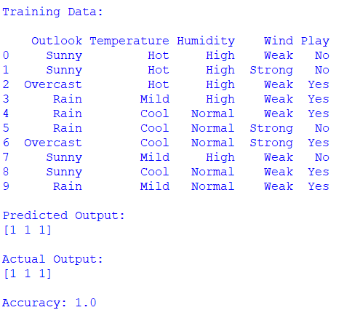
Result
Thus, the Logistic Regression algorithm was implemented successfully and the accuracy was obtained.

Experiment 8: Linear Regression
Aim
To implement the Linear Regression Algorithm in Python.
Algorithm
- Import the required libraries.
- Read the dataset (LinearRegression.csv).
- Display the dataset.
- Separate input and output.
- Create the Linear Regression model.
- Train the model.
- Predict the output.
- Display the predicted result.
Coding
import pandas as pd
from sklearn.linear_model import LinearRegression
# Read CSV file
data = pd.read_csv("LinearRegression.csv")
print("Training Data:\n")
print(data)
X = data[['Hours']]
y = data['Marks']
model = LinearRegression()
model.fit(X, y)
prediction = model.predict([[7]])
print("\nPredicted Marks for 7 Hours:")
print(prediction)
Output
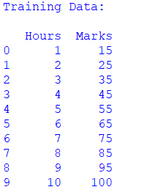
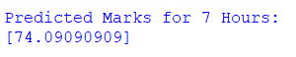
Result
Thus, the Linear Regression algorithm was implemented successfully and the predicted output was obtained.

Experiment 9: Compare Linear and Polynomial Regression
Aim
To compare the performance of Linear Regression and Polynomial Regression using Python.
Algorithm
- Import the required libraries.
- Read the dataset (PolynomialRegression.csv).
- Separate input and output.
- Train the Linear Regression model.
- Convert input into polynomial features.
- Train the Polynomial Regression model.
- Predict using both models.
- Compare the outputs.
Python Code
import pandas as pd
from sklearn.linear_model import LinearRegression
from sklearn.preprocessing import PolynomialFeatures
# Read CSV file
data = pd.read_csv("PolynomialRegression.csv")
print("Training Data:\n")
print(data)
X = data[['Experience']]
y = data['Salary']

linear = LinearRegression()
linear.fit(X, y)
poly = PolynomialFeatures(degree=2)
X_poly = poly.fit_transform(X)
poly_model = LinearRegression()
poly_model.fit(X_poly, y)
linear_prediction = linear.predict([[6]])
poly_prediction = poly_model.predict(poly.transform([[6]]))
print("\nLinear Regression Prediction:")
print(linear_prediction)
print("\nPolynomial Regression Prediction:")
print(poly_prediction)
Output:
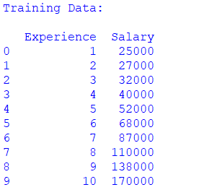
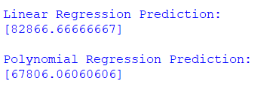
Result
Thus, the Linear Regression and Polynomial Regression models were implemented successfully and their predictions were compared.

Experiment 10: Expectation Maximization (EM) Algorithm
Aim
To implement the Expectation Maximization Algorithm using the Gaussian Mixture Model in Python.
Algorithm
- Import the required libraries.
- Read the dataset (ExpectationMaximization.csv).
- Display the dataset.
- Select the input features.
- Create the Gaussian Mixture Model.
- Train the model.
- Predict the cluster labels.
- Display the cluster labels.
Python Code
import pandas as pd
from sklearn.mixture import GaussianMixture
# Read CSV file
data = pd.read_csv("ExpectationMaximization.csv")
print("Training Data:\n")
print(data)
X = data[['Height', 'Weight']]
model = GaussianMixture(n_components=2, random_state=1)
model.fit(X)
prediction = model.predict(X)
print("\nCluster Labels:")
print(prediction)

Output:
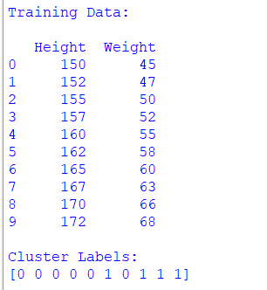
Result
Thus, the Expectation Maximization algorithm was implemented successfully, and the data points were grouped into clusters successfully.

